Alaska Groundfish Stock Assessment Guidelines

Alaska Fisheries Science Center

July 2024

**Table of Contents**

1. Introduction

1.1. September Plan Team Products

1.2. November Plan Team Products

1.3. December Council Products

1.4. Assessment Product Schedule

1.5. Unforeseen Circumstances

2. Outline and Format of Stock Assessments

3. Assessment Definitions

4. Operational Full and Update Guidelines

4.1. Title Page and Authorship

4.2. Executive Summary

4.2.1. Summary of Changes in Assessment Inputs

4.2.2. Summary of Results

4.2.3. Tier 1 Template

4.2.4. Tier 3 Template

4.2.5. Tier 5 template

4.2.6. Tier 6 template

4.2.7. Responses to SSC and Plan Team Comments

4.2.7.1 General Stock Assessment Comments

4.2.7.2 Comments Specific to this Assessment

4.2.7.3 Comments in Update Stock Assessments

4.3 Introduction

4.3.1 Introduction: Update Stock Assessments

4.4. Fishery and Management History

4.4.1. Fishery and Management History: Update Stock Assessments

4.5. Data

4.5.1. Fishery Data

4.5.1.1 Fishery Data: Update Stock Assessments

4.6. Survey Data

4.7. Other Data

4.8. Analytic Approach

4.8.1. Analytic Approach: Update Stock Assessments

4.8.2. Description of Alternative Models

4.9. Age Structured Model Results: Tiers 1-3

4.9.1. Tables

4.9.2. Figures

4.9.3. Evaluation of Model(s) and Associated Uncertainty

4.9.4. Sensitivity to Model Specification

4.9.5. Convergence Status and Criteria

4.9.6. Likelihood Profiles on Key Parameters

4.9.7. Retrospective analysis (within model)

4.9.8. Historical retrospectives (between models)

4.10. Results: Tier 4-6

4.11. Projections and Harvest Recommendations

4.11.1. Amendment 56 Reference Points

4.11.2. Specification of OFL and Maximum Permissible ABC

4.11.3. Standard Harvest Scenarios and Projection Methodology: Tiers 1-3

4.12. Risk Table and ABC Recommendation

4.13. Area Allocation of ABC

4.14. Status Determination

4.15. Flimit

4.16. Ecosystem Considerations

4.17. Ecosystem Effects on the Stock

4.18. Fishery Effects on the Ecosystem

4.19. Data Gaps and Research Priorities

4.20. Acknowledgements

4.21. Literature Cited

4.22. Auxiliary Files

4.23. Tables

4.24. Figures

4.25. Appendices and Working Papers

5. Harvest Projection Guidelines

5.1. Title Page and Authorship

5.2. Executive Summary

5.2.1. Description of Updated Catch

5.2.2. Summary of Results

5.2.3. Harvest Projection Template

5.2.4 Figures

6. References: Alaska Groundfish Stock Assessment Guidelines

# 1. Introduction

The purpose of this document is to outline the guidelines for producing individual groundfish stock assessments produced by the Alaska Fisheries Science Center (AFSC) that compose contributions to the annual North Pacific Fishery Management Council (NPFMC, Council) Stock Assessment and Fishery Evaluation (SAFE) reports for the October and December meetings. In this document, the term “stock assessment” includes activities, analyses and reports, beginning with data collection and continuing through to scientific recommendations presented to the Council and its advisors. This document applies to stock assessments of NPFMC federally managed groundfish species. Draft stock assessments are subject to in-house reviews prior to being peer reviewed at meetings of the Groundfish Plan Teams (GPT) held in September and November, prior to further Science and Statistical Committee (SSC) review and acceptance as the Best Scientific Information Available (BSIA) for decision making during the October and December NPFMC meetings.

The stock assessment authors are responsible for conducting a complete and technically sound stock assessment that conforms to accepted standards of quality, and in accordance with these Guidelines. The recommended stock assessment types are provided in the 2023 [AFSC stock assessment definitions](https://drive.google.com/drive/u/0/folders/1Bc2xUp8Ls_GmnNmpJ17OogJh1klqMmWS). The draft assessment documents for operational full, operational update, and harvest projection assessments should follow the outline and formats in this document. Guidance for addressing specific topics related to assessment products are provided in appendices to this document. This includes “best practices” recommendations for specific topics such as model evaluation criteria, diagnostic tools, projection scenarios, recruitment assumptions, etc. Authors are not limited to using only the guidance provided here but should incorporate these best practices to the extent practicable.

The stock assessment authors are responsible for preparing three versions of the stock assessment document for the AFSC and NPFMC peer review process by the stated deadlines:

1. an “internal draft” for agency review
2. a “Plan Team draft” publicly available prior to the GPT meeting; and
3. a “final version” for presentation to the SSC and Council Advisory Bodies.

To ensure adequate time for internal AFSC review of stock assessments, documents are due for in-house review approximately 2-3 weeks prior to GPT meetings. Documents are due to the GPTs at least 7 days prior to the start of the meeting. Please refer to the annual Stock Assessment Assignment Memo for specific dates. Note that after the version is presented to, and adopted by the Council that the final document will be posted without the decision disclaimer.

Stock assessment authors are responsible for maintaining model files and data (in digital format) for internal and Council review processes, including all files needed to run the model as well as a standard set of model output files, tables, and plots. Document links embedded in SAFE documents are allowed, but only for referencing supporting material in addition to the standard model output tables and plots. The AFSC is currently in the process of standardizing how digital material should be presented and archived for stock assessments and will provide further guidance when available.

## 1.1. September Plan Team Products

The September Plan meeting provides an opportunity to review preliminary stock assessment work and research models expected to be recommended for management advice in November. This may include the following:

1. Proposed changes to operational full stock assessments made since the last full stock assessment. These changes may include improvements to the base model, supporting rationale to be considered for upgrading to a higher Tier level, or consideration of a research assessment model submitted as an operational assessment in November.
2. Research into new methodologies or analyses external to the assessment model that may be implemented in November and may impact management advice. Examples include new maturity studies, growth analyses, etc.
3. Specific responses to previous GPT or SSC recommendations or comments that require review or further recommendations before implementation in the November assessment.
4. Responses to CIE review comments or recommendations that change the base model and result in an alternative model.

The products prepared for the September GPT review should include a document and presentation with preliminary data analyses and stock assessment model runs that provide the GPTs with enough information to make decisions about new models or analyses that will be considered by the GPT in September, and the SSC in October. In general, no new data since the last full assessment should be included in base model runs if the intent is to compare and improve methods. New data will be presented when the model is put forth in November for harvest recommendations. If the SSC accepts the new model, the November assessment should include the base model information and results from the previous assessment, and the new model information and results.

September drafts must be submitted to Council Plan Team Coordinators, and cc’d to all SSMA and MESA supervisors and respective Plan Team co-chairs, by the date listed in the annual stock assessment memo approximately one week prior to the September GPT meetings. GPT presentations are due to coordinators no later than 24 hours prior to scheduled agenda times. The GPT co-chairs and Council coordinators typically present a GPT report including summaries of September GPT meeting agenda items to the Council review bodies during the October Council meeting. Authors may be asked to help the co-chairs and coordinators to prepare these presentations or authors may be asked to present their work to the SSC, AP, or Council. Authors should work with GPT co-chairs, Council coordinators, and supervisors to coordinate presentations and travel to the October Council meeting if required.

## 1.2. November Plan Team Products

All operational full, operational update, and harvest projection stock assessments must be fully documented and presented at the November GPT meetings. Stock assessments should include all sections listed in Appendices A, B, and C, that outline the structure for each type of stock assessment product. The outline is intended to provide a consistent structure for stock assessments conducted at the AFSC for BSAI and GOA groundfish fisheries.

November assessment drafts must be submitted to Council Plan Team Coordinators, and cc’d to all SSMA and MESA supervisors and respective Plan Team co-chairs, by the date listed in the annual stock assessment memo approximately one week prior to the November GPT meetings. No substantial changes should be made between submission of the document, posting, and presentation to the GPT. GPT presentations shall reflect what’s in the document. Any deviations from what’s in the document should be discussed with supervisors and/or GPT co-chairs and coordinators and approved before presenting. GPT presentations are due to Council Plan Team Coordinators no later than 24 hours prior to scheduled agenda times. Authors are expected to address minor edits to the document during Plan Team week if requested and must provide a finalized “draft” prior to the end of the November GPT meeting for submission to the Council and posting for the public. No changes to assessment documents are allowed following posting to the public for the December meeting. If authors are asked to present to the SSC/AP/Council, presentations shall reflect what’s in the final document.

## 1.3. December Council Products

Final assessments will be submitted by authors during the week of the November GPT meetings, no later than the last day of the meetings. GPT co-chairs typically present assessment results to the SSC, AP, and Council at the December Council meeting as part of the Plan Team report but may need assistance from authors to prepare these presentations. In some cases, authors may be asked to present to the review bodies during the December meeting. Authors should work with GPT co-chairs, Council coordinators, and supervisors to coordinate presentations and travel to the December Council meeting if required.

The Species Information System (SIS) database serves as the national repository for stock assessment results, status determination results, and annual catch limit information. Authors are required to provide stock status information through the SIS data call that occurs annually following completion of stock assessments. This data call and deadlines will be coordinated by our local AFSC SIS Point of Contact and will be distributed in late November or early December.

## 1.4. Assessment Product Schedule

Stock assessment prioritization recommendations were developed in partnership with the NPFMC in 2017 and 2023. A stock assessment schedule was developed defining what assessment products are due and the frequency for every assessment Tier level. The assessment product schedule is based on Tier level, and frequency is in one, two or four-year increments for all groundfish stock assessments. The annual stock assessment memo provides information on which stock assessments are expected to be full and update stock assessments in a given year.

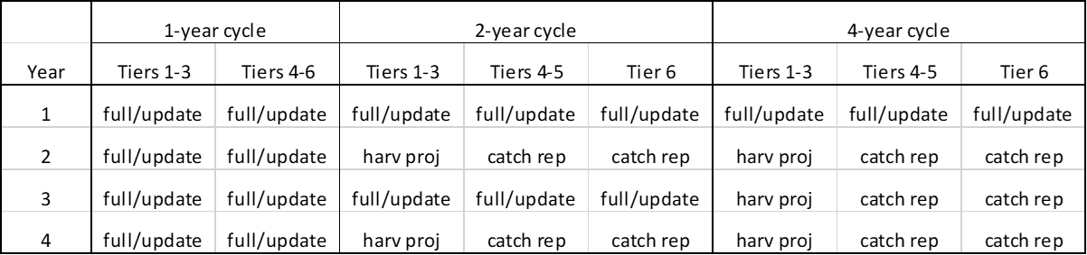

*full/update (full or update operational assessment); harv proj (harvest projection); catch rep (catch report).

Note: catch reports are drafted by Council staff. Authors are not required to submit a document.

## 1.5. Unforeseen Circumstances

Authors should be proactive throughout the year to ensure the highest quality work is conducted in a timely manner. If circumstances arise throughout the year that may disrupt the author’s ability to meet required deadlines, authors should inform their supervisors immediately and work closely with Plan Team co-chairs and Council staff. When these circumstances arise, it’s imperative for timely and frequent communication between authors and their supervisors.

# 2. Outline and Format of Stock Assessments

This is a general outline of elements that should be included in each type of stock assessment document for groundfish managed by the North Pacific Fishery Management Council. The outline is a guide to organize and communicate required stock assessment results.

Please **omit** any headers, page numbers, and footers on the version of drafts submitted for dissemination to the Plan Teams or Council, these will be added by Council staff. Use of section heading styles in Word (heading 1, heading 2, etc.) and 11 point times new roman font for the main text. Please allow 1 inch margins (72 points) and be sure the tables or figures don’t overlap the margins. Please use the chapter numbers as they appear in the tasking memo.

# 3. Assessment Definitions

An operational full assessment is the most comprehensive type of assessment and should be the most detailed of all the assessment products since all available data and model configurations are presented for consideration.

An operational update assessment is conducted when updating the last full assessment model structure with current data, and maintains the accepted model configuration This assessment type must carry forward the fundamental structure of the last operational full assessment reviewed and endorsed through the NPFMC review process. Therefore, the content presented in an operational update assessment can be considered an abbreviated version of the last operational full assessment, and the majority of sections that do not directly inform review bodies on making a management decision can be presented in a condensed form and referenced from the last operational full assessment. Update assessments should use the most recent software versions when possible. If bridging an operational update stock assessment from older to newer software yields unexpected results, a full operational stock assessment with results and a discussion of the significant differences between the old and new software version results may be necessary. Changing from an operational update stock assessment to an operational full stock assessment will require presentation of results at the September/October meetings. Supervisors and Plan Team co-chairs should be informed if the assessment needs to be elevated to a full operational assessment.

Harvest projection assessments provide stock projections (Tiers 1-3) or catch/biomass ratios (Tiers 4-5) that are updated with recent catch data, but do not include the most recent survey abundance index estimates which are only presented in the document. These assessments consist of an executive summary.

Catch reports are brief and provide total catch relative to recent catches and ABC (landings and discards). At this time, authors are not responsible for producing catch reports for their stocks, but they are responsible for tracking their stock and reviewing fishery catch statistics in relation to ABCs even when an assessment isn’t due.

# 4. Operational Full and Update Guidelines

SAFE document requirements and guidelines for assessment products differ depending on assessment type. The following table outlines the elements and sections required to produce a SAFE document for each of the stock assessment types. For abbreviated sections in operational update assessments, authors are encouraged to reference the previous operational full assessment where methods do not differ appreciably. Further details are provided in the accompanying text and appendices at the end of this document. For ease of review, consider including a Table of Contents as well as lists of Tables and Figures.

|  | **Assessment Type** | | | |
| --- | --- | --- | --- | --- |
| **Section** | **Operational Full** | **Operational Update** | **Harvest Projection** | **Catch Report** |
| Title Page/Authorship | Yes | Yes | Yes | No |
| Executive Summary |  |  |  |  |
| Summary of Changes to Assessment Inputs | Yes | Yes | Yes | No |
| Summary of Results | Yes | Yes | Yes | No |
| Responses to SSC/Plan Team Comments in general | Yes | Abbreviated | No | No |
| Responses to SSC/Plan Team Specific to assessment | Yes | Abbreviated | No | No |
| Introduction | Yes | Abbreviated | No | No |
| Fishery and Management History | Yes | Abbreviated | No | No |
| Data | Yes | Yes | No | No |
| Fishery | Yes | Abbreviated | No | No |
| Survey | Yes | Abbreviated | No | No |
| Other | As Needed | As Needed | No | No |
| Analytic Approach |  |  |  |  |
| Description of alternative models | Yes | No | No | No |
| Results |  |  |  |  |
| Tables | Yes | Yes | No | No |
| Figures | Yes | Yes | No | No |
| Evaluation of Model(s) and Associated Uncertainty | Yes (Tier 1-3) | Yes (Tier 1-3) | No | No |
| Sensitivity to Model Specification | Yes (Tier 1-3) | Yes (Tier 1-3) | No | No |
| Convergence Status and Criteria | Yes (Tier 1-3) | Yes (Tier 1-3) | No | No |
| Likelihood Profiles on Key Parameters | Yes (Tier 1-3) | Yes (Tier 1-3) | No | No |
| Retrospective Analysis | Yes (Tier 1-3) | Yes (Tier 1-3) | No | No |
| Historic Retrospectives | Yes (Tier 1-3) | Yes (Tier 1-3) | No | No |
| Projections and Harvest Recommendations |  |  |  |  |
| Amendment 56 reference points | Yes | Yes | No | No |
| Specification of OFL and ABC | Yes (Tiers 1-5) | Yes (Tiers 1-5) | Yes | No |
| Standard Harvest Scenarios | Yes (Tiers 1-3) | Yes (Tier 1-3) | No | No |
| Risk table and ABC recommendation | Yes | Yes | No | No |
| Area allocation of ABC | Yes | Yes | Abbreviated | No |
| Status determination | Yes | Yes | No | No |
| *F* limit | Yes (Tiers 1-3) | Yes (Tiers 1-3) | No | No |
| Ecosystem Considerations |  |  |  |  |
| Ecosystem effects on the stock | Yes | Abbreviated | No | No |
| Fishery effects on the stock | Yes | Abbreviated | No | No |
| Data Gaps and research priorities | Yes | Yes | No | No |
| Acknowledgements | Yes | Yes | No | No |
| Literature cited | Yes | Yes | Yes | No |
| Auxiliary files | As Needed | As Needed | No | No |
| Tables | Yes | Yes | As Needed | No |
| Figures | Yes | Yes | As Needed | No |
| Appendices and working papers | As Needed | As Needed | No | No |

## 4.1. Title Page and Authorship

Please use the following convention: “Assessment of the *Myfish* stock in the *Gulf of Alaska*” for single-stock assessments and “Assessment of the *Myfish* stock complex in the *Gulf of Alaska*” for multi-stock assessments (replacing italicized text appropriately).

Authorship shall be decided following the [AFSC stock assessment authorship guidelines](https://docs.google.com/document/d/12q1CDpfWkOYi9CoJks-KPrHRY_JerIE7qRmm8__6WgI/edit).

The title page should include text on how to cite the assessment document, based on the following example.

This report may be cited as:

Authors., Year. Title. North Pacific Fishery Management Council, Anchorage, AK. Available from https://www.npfmc.org/library/safe-reports/

## 4.2. Executive Summary

### **4.2.1. Summary of Changes in Assessment Inputs**

List of changes (if any) in the input data, including estimated catches assumed for the current year and projected catches for current year + 1 and current year + 2.

List of changes (if any) in the assessment methodology. **This is one of the most important sections of the SAFE report.** Common mistakes in this section include: 1) listing something that *has not* changed, and 2) *not* listing something that *has* changed.

### **4.2.2. Summary of Results**

Text table showing *M*; recommended Tier; projected total biomass (give age range); female spawning biomass; equilibrium female spawning biomass values for *B0* and *BMSY* (Tier 1 only) or *B100%*, *B40%*, and *B35%* (Tier 3 only); *FOFL*; the maximum allowable value for *FABC*; the recommended value for *FABC*; OFL; the maximum allowable ABC, and the recommended ABC. State whether the stock or complex is being subjected to overfishing, is currently overfished, or is approaching a condition of being overfished. Compare all of the above to the corresponding values from last year’s final assessment (or final specifications, if different from the assessment values). Tier-specific templates for this table are shown on the following pages (**notes: 1) the rows labeled “Female spawning biomass (t)” and “Projected” for Tiers 1 and 3 and the row labeled “Biomass (t)” for Tier 5 are headers, so please do not put anything in those rows; 2) the “x” in “age x+” should be replaced with the appropriate value for stocks in Tiers 1 or 3; and 3) cells with “current year…” should be replaced with the appropriate number, where “current year” means *this year***). A brief discussion of substantial changes in results from last year may be included if it helps explain the summary table.

### **4.2.3. Tier 1 Template**

| **Quantity** | As estimated or  *specified last* year for: | | As estimated or *recommended this* year for: | |
| --- | --- | --- | --- | --- |
| current year | current year + 1 | current year* + 1 | current year* + 2 |
| *M* (natural mortality rate) |  |  |  |  |
| Tier |  |  |  |  |
| Projected total (age x+) biomass (t) |  |  |  |  |
| Projected Female spawning biomass )t_(t) |  |  |  |  |
| *B0* |  |  |  |  |
| *BMSY* |  |  |  |  |
| *FOFL* |  |  |  |  |
| *maxFABC* |  |  |  |  |
| *FABC* |  |  |  |  |
| OFL (t) |  |  |  |  |
| maxABC (t) |  |  |  |  |
| ABC (t) |  |  |  |  |
| **Status** | As determined *last* year for: | | As determined *this* year for: | |
| current year − 2 | current year − 1 | current year − 1 | current year |
| Overfishing |  | n/a |  | n/a |
| Overfished | n/a |  | n/a |  |
| Approaching overfished | n/a |  | n/a |  |

*Projections are based on estimated catches of xx,xxx t and xx,xxx t used in place of maximum permissible ABC for current year + 1 and current year + 2.

### **4.2.4. Tier 3 Template**

| **Quantity** | As estimated or  *specified last* year for: | | As estimated or  *recommended this* year for: | |
| --- | --- | --- | --- | --- |
| current year | current year + 1 | current year* + 1 | current year* + 2 |
| *M* (natural mortality rate) |  |  |  |  |
| Tier |  |  |  |  |
| Projected total (age x+) biomass (t) |  |  |  |  |
| Projected Female spawning biomass )t_(t) |  |  |  |  |
| *B100%* |  |  |  |  |
| *B40%* |  |  |  |  |
| *B35%* |  |  |  |  |
| *FOFL* |  |  |  |  |
| *maxFABC* |  |  |  |  |
| *FABC* |  |  |  |  |
| OFL (t) |  |  |  |  |
| maxABC (t) |  |  |  |  |
| ABC (t) |  |  |  |  |
| **Status** | As determined *last* year for: | | As determined *this* year for: | |
| current year − 2 | current year − 1 | current year − 1 | current year |
| Overfishing |  | n/a |  | n/a |
| Overfished | n/a |  | n/a |  |
| Approaching overfished | n/a |  | n/a |  |

*Projections are based on estimated catches of xx,xxx t and xx,xxx t used in place of maximum permissible ABC for current year + 1 and current year + 2.

### **4.2.5. Tier 5 template**

| **Quantity** | As estimated or  *specified last* year for: | | As estimated or  *recommended this* year for: | |
| --- | --- | --- | --- | --- |
| current year | current year + 1 | current year + 1 | current year + 2 |
| *M* (natural mortality rate) |  |  |  |  |
| Tier |  |  |  |  |
| Biomass (t) |  |  |  |  |
| *FOFL* |  |  |  |  |
| *maxFABC* |  |  |  |  |
| *FABC* |  |  |  |  |
| OFL (t) |  |  |  |  |
| maxABC (t) |  |  |  |  |
| ABC (t) |  |  |  |  |
| **Status** | As determined *last* year for: | | As determined *this* year for: | |
| current year − 2 | current year − 1 | current year − 1 | current year |
| Overfishing |  | n/a |  | n/a |

### **4.2.6. Tier 6 template**

| **Quantity** | As estimated or  *specified last* year for: | | As estimated or  *recommended this* year for: | |
| --- | --- | --- | --- | --- |
| current year | current year + 1 | current year + 1 | current year + 2 |
| Tier |  |  |  |  |
| OFL (t) |  |  |  |  |
| maxABC (t) |  |  |  |  |
| ABC (t) |  |  |  |  |
| **Status** | As determined *last* year for: | | As determined *this* year for: | |
| current year − 2 | current year − 1 | current year − 1 | current year |
| Overfishing |  | n/a |  | n/a |

Text table of area apportionments (if any) for the recommended one- and two-year ahead ABCs and OFLs, with a brief description of the apportionment methodology.

### **4.2.7. Responses to SSC and Plan Team Comments**

SSC and Plan Team comments and recommendations should be reviewed by all authors. Recommendations specific to groundfish assessments are generally made during the September/October and November/December meetings. Recommendations can be found in the Plan Team and SSC reports to the Council on the Council website under Council meeting archives.

#### **4.2.7.1 General Stock Assessment Comments**

Responses to SSC and Plan Team comments on assessments in general (for each comment that is addressed in the main text, list comment, and reference the section where it is discussed). *If the SSC or Plan Team did not make any comments on assessments in general, say so. If the author does not have the capacity to address general assessment recommendations specific to their stock note which general recommendations are outstanding.*

#### **4.2.7.2 Comments Specific to this Assessment**

Responses to SSC and Plan Team comments specific to this assessment (for each comment that is addressed in the main text, list comment and reference the section where it is discussed). **If the SSC or Plan Team did not make any comments specific to this assessment, say so**.

#### **4.2.7.3 Comments in Update Stock Assessments**

For update assessments, authors should include all outstanding recommendations and comments made including those from the last assessment cycle. It is the author’s discretion to address these recommendations or defer until the next full assessment.

## 4.3 Introduction

Scientific name

Description of general biology and distribution

Description of key life history characteristics specific to stock assessments (e.g., special features of reproductive biology)

Evidence of stock structure, if any

### **4.3.1 Introduction: Update Stock Assessments**

For update assessments, reference the last full operational stock assessment for the full description of the general biology and life history. Include abbreviated text highlighting relevant information for making management decisions.

## 4.4. Fishery and Management History

Brief description of fishery history

Description of management measures/unit(s)

* Management history (including key changes which may have influenced assessment procedures; selectivity of commercial fishing gear; or distribution of catch by gear, area, or season.
* Include a table of total catch, total ABC, total OFL, and total TAC, and associated management measures

Description of the current directed fishery (including gear types, seasons, major fishing locations)

Information on discards of this stock or stock complex (from directed fishery for this stock or stock complex)

### **4.4.1. Fishery and Management History: Update Stock Assessments**

For update models, reference the last full operational stock assessment for the full description of fishery history noting any significant recent changes to the fishery (including gear types, seasons, locations) or management measures.

Include a table with the time series of total catch, total ABC, total OFL, and total TAC, and associated management measures.

Reference the last full operational stock assessment for information on discards of this stock or stock complex (from directed fishery for this stock or stock complex). Provide text on updated information on discards and note any significant changes.

## 4.5. Data

Note: If the data for any particular component described here are so voluminous that the corresponding tables would comprise more than 2 pages, the tables may be placed on an ftp site referenced in the chapter.

For Tiers 1-3, insert a table summarizing the data used in the assessment model (source, type, years included). The following is a typical example:

| **Source** | **Data** | **Years** |
| --- | --- | --- |
| NMFS Groundfish survey | Survey biomass | 1984-1999 (triennial), 2001-2013 (biennial) |
|  | Age Composition | 1984, 1987, 1990, 1993, 1996, 1999, 2003, 2005, 2007, 2009, 2011 |
| U.S. trawl fisheries | Catch | 1961-2013 |
|  | Age Composition | 1990,1998-2002, 2004, 2005, 2006, 2008, 2010 |
|  | Length Composition | 1963-1977, 1991-1997 |

### **4.5.1. Fishery Data**

Table of catch as used in the model (by area and gear if that is how it is used in the model). This table may be omitted if this table simply duplicates the catch table shown under “Management units/measures”).

In an appendix, present removals from sources other than those that are included in the Alaska Region’s official estimate of catch (e.g., removals due to scientific surveys, subsistence fishing, recreational fishing, fisheries managed under other FMPs).

Catch estimates are uploaded from the Catch Accounting System (CAS) and updated in AKFIN on October 1 of the assessment year. Full and update assessments should query the most recent catch estimates for use in the November assessment on or soon after October 1. Catch estimates for use in projection models should be extrapolated to the full year ending on December 31 with rationale for how the extrapolation is done.

Catch at age or catch at length (including sample sizes),should be included as appropriate.

Description of effort and CPUE.

#### **4.5.1.1 Fishery Data: Update Stock Assessments**

For update models, include a table of catch as used in the model (by area and gear if that is how it is used in the model). This table may be omitted if this table simply duplicates the catch table presented in the “Fishery and Management History” section above.

Catch at age or catch at length (including sample sizes), should be included as appropriate.

## 4.6. Survey Data

Survey biomass estimates, including at least one measure of sampling variability such as standard error, *CV*, or 95% confidence interval (for stocks managed as complexes, be sure to report the sampling variability for the complex-wide survey biomass estimate, not just the individual stocks). Complex-wide variance could be computed simply by summing the variances from the survey estimates.

Alternative survey biomass indexes used for management advice, such as VAST biomass estimates, should be appropriately documented including comparisons to design-based methods and providing sufficient diagnostics to evaluate fit and use of these alternative indices. An example VAST appendix is [here](https://apps-afsc.fisheries.noaa.gov/Plan_Team/2022/GOAdusky.pdf).

Provide a table of relevant sample sizes for composition data such as number of survey trawl tows or longline sets/hooks and number of fish for each year.

Provide survey numbers at age or numbers at length as an electronic file.

## 4.7. Other Data

## 4.8. Analytic Approach

Description of overall modeling approach (e.g., age/size structured versus biomass dynamic, maximum likelihood versus Bayesian)

If standardized software (e.g., Stock Synthesis) is used, give reference to technical documentation where variables and equations are described. If standardized software is not used, then list variables and equations used in the assessment model(s) in tables or appendices as appropriate.

### **4.8.1. Analytic Approach: Update Stock Assessments**

For update assessments, include a description of the base model included in the assessment, including a reference to the last full operational assessment when the base model was used for management advice.

Documentation of any minor modeling changes to the previously accepted model used for management.

### **4.8.2. Description of Alternative Models**

Description of alternative models included in the assessment, if any (e.g., alternative *M* values or likelihood weights); **note that the base model (i.e., the model most recently accepted by the SSC, either after reviewing the previous year’s final assessment or the current year’s preliminary assessment) must be included.**

Per recommendation of the SSC (10/15), please use the following convention for numbering models:

When a model constituting a “major change” from the original version of the base model is introduced, it is given a label of the form “Model *yy.j*,” where *yy* is the year (designated by the last two digits) that the model was introduced, and *j* is an integer distinguishing this particular “major change” model from other “major change” models introduced in the same year.

When a model constituting only a “minor change” from the original version of the base model is introduced, it is given a label of the form “Model *yy.jx*,” where “*x*” is a letter distinguishing this particular “minor change” model from other “minor change” models derived from the original version of the same base model.

Specifically, please use one of the following four options to distinguish “major” from “minor” changes:

*Option A*

The *original version of the base model* is the base model from the earliest year relative to which the current base model constitutes only a minor change.

If Model *yy.j* is the original version of the base model and some other model (provisionally labeled “Model *M*”) is introduced in year 20*zz*, define the “average difference in spawning biomass” (ADSB) between Model *M* and Model *yy.j* as:

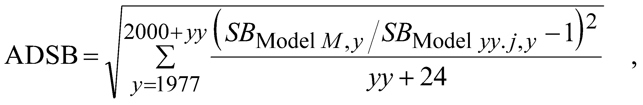

where both models are run with data through the year 20*yy* only (i.e., the year in which the original version of the base model was introduced). If ADSB<0.1, the final name of Model *M* should be of the form “Model *yy.jx*,” where “*x*” is a letter. If ADSB≥0.1, the final name should be of the form “Model *zz.i*,” where “*i*” is an integer. For Tiers 4-5, survey biomass may be used in place of spawning biomass in the above.

*Option B*

Same as Option A, except that the model approved by the SSC in 2014 is considered to be the original version of the base model in all cases. **The SSC noted that Option B can be used if Option A “poses a significant time commitment for the analyst.”**

*Option C*

Same as Option A, except that the distinction between “major” and “minor” model changes is determined subjectively by the author on the basis of qualitative differences in model structure rather than the performance-based criterion described in Option A. **The SSC noted that Option C can be used “where needed.”**

*Option D*

Options B and C combined.

## 4.9. Age Structured Model Results: Tiers 1-3

This section should be omitted for Tiers 4-6. For Tiers 1-3, items in this section pertain to the author’s recommended model. Documentation of model results differ depending on assessment type. The following table outlines the results presented for operational full and update stock assessments. Provide text to interpret the tables and figures listed below, ensuring a clear description of units for all outputs on figures and plot headers. Describe and interpret notable differences between the previously SSC accepted (base) model and alternative models for derived quantities, estimated/fixed parameters, and fits to data. Define biomass units used (e.g., age range used in the “age+” biomass) and recruitment units used (e.g., numbers at age 3. The definitions should match those reported in the Executive Summary Table and in the Harvest Projections section.

| Model Type | | Full | Update  (Nov. PT only) |
| --- | --- | --- | --- |
| **Model Results** | Time series of derived quantities, with uncertainty intervals, for recommended and base models | Sept & Nov | ✔ |
| Fits to all data sources | Sept & Nov | ✔ |
| Parameter estimates, with uncertainty | Sept & Nov | ✔ |
| **Model Evaluation** | Sensitivity to model specification  (e.g., dropping datasets, LOO, Steepness, M). Can be hosted as an external file. | Sept |  |
| Convergence status and criteria, including jitter analysis or evidence that posterior sampling is adequate if Bayesian methods are used. | Sept & Nov | ✔ |
| Likelihood profile(s) on key parameters | Sept |  |
| 10-year retrospective analysis (biomass), with uncertainty intervals if feasible | Sept & Nov |  |
| Comparison of past assessment estimates | Sept & Nov |  |

### **4.9.1. Tables**

* 1. Table listing all parameters in the stock assessment model used for the author’s proposed model and for the previously accepted model, their purpose (e.g., recruitment parameter, selectivity parameter) and whether or not the parameter was fixed or estimated in the stock assessment model, and values estimated or used (if fixed). Include the associated asymptotic standard error estimates or other statistical measures of uncertainty for estimated parameters.
  2. Table(s) of time-series of total biomass, spawning biomass (and/or spawning output), recruitment, and fishing mortality. Time-series quantities should be reported with confidence bounds or other statistical measure of uncertainty, for the author’s proposed model. Include results for both the author’s recommended model and the previously accepted model in table and figures.
  3. Table of estimated numbers-at-age by year (as an electronic file, if desired).
  4. A listing of input (starting) sample sizes used for all composition data by year and final values if any data weighting through variance adjustments and any other adjustments to the relative weights assigned to objective function components.

### **4.9.2. Figures**

1. Figure(s) of time-series of total biomass, spawning biomass (and/or spawning output), and recruitment and fishing mortality. Time-series quantities should be plotted with confidence bounds or other statistical measure of uncertainty. **Include results and statistical measures of uncertainty for both the author’s proposed model and the previously accepted model in the tables, figures, or both.**
2. Figure(s) showing time-series of model fits to survey and fishery indices fit within the model. Where feasible, standard deviation of normalized residuals (SDNRs) should be reported for fits to index data (these can be reported directly on the plot).
3. Figures showing fits to composition data and conditional age-at-length data by year and by any other major structural definition in the assessment, such as area or season for the base model, including residual analyses.
   1. Yearly fits to composition data and conditional age-at-length data. If comparing multiple models, such comparison plots can be shown in the “Model Evaluation” section.
   2. Fits to composition and conditional age-at-length data aggregated over time, disaggregated by area or season (if used), accounting for sample sizes used. If comparing multiple models, these plots can be shown in the “Model Evaluation” section. Examples:

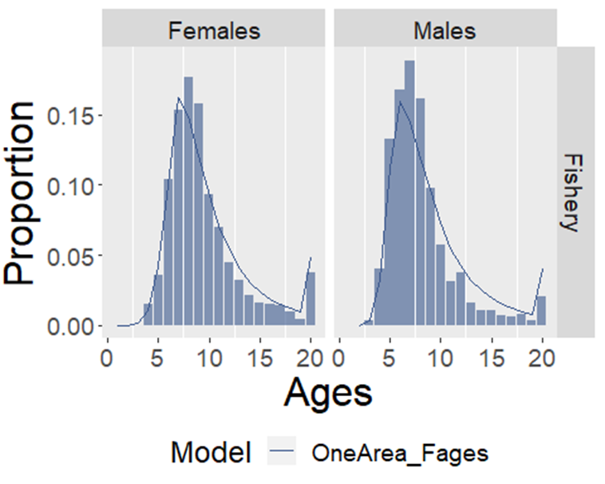

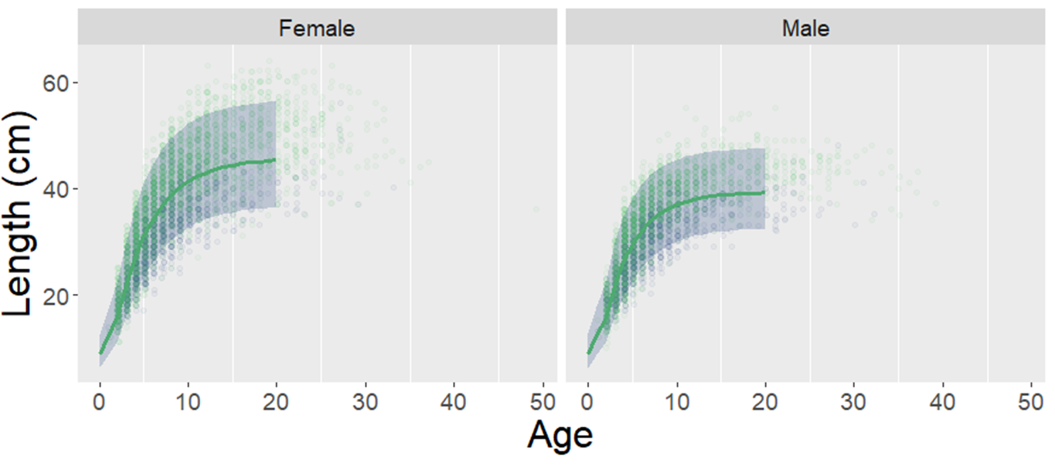

* 1. In a “full” assessment, include one-step-ahead residuals, and/or Pearson residuals.

1. Figure(s) showing selectivity curves for all fishery and index fleets, by sex and by year (if appropriate).
2. Figure(s) showing growth and maturity curves, by sex and by year, with associated uncertainty (if applicable).
3. Figure of time series of recruitment deviations with associated uncertainty.
4. Figure showing the stock-recruitment relationship, if one is used. Specify whether the stock-recruitment relationship was fit within the model, or was estimated separately using the model estimates of recruitment and spawning biomass outside of the main assessment model. Describe methodology used.
   1. Figure of estimated fishing mortality versus estimated spawning stock biomass (phase-plane plot), including applicable OFL and maximum *FABC* definitions for the stock. Biomass should be scaled relative to *BMSY* for Tier 1 stocks and *B35%* for Tier 3 stocks. Fishing mortality should be scaled relative to the arithmetic mean of *FMSY*for Tier 1 stocks and *F35%* for Tier 3 stocks. Include 2 years of projected *F* and *B* in the phase-plane plot.

### **4.9.3. Evaluation of Model(s) and Associated Uncertainty**

For Full Assessments, all components (listed below) are requested for the author’s proposed model, a subset is requested for alternative models that are not the author’s proposed new base model. “Alternative Models” include wholly different model configurations presented as true alternatives to the previous base model, and include the author’s proposed model. Sensitivity models are those run simply to illustrate the behavior of the proposed base model(s), and are not considered “Alternative Models”. To avoid redundancy, we ask that authors provide both the result(s) of these analyses and interpretation of the results in the same section.

If the outcome of a given diagnostic was used to discard an alternative assessment model, that must be stated clearly within this section with justification. Authors are permitted to include additional diagnostics than those requested here, or to include diagnostics that are not requested for a certain model category, at their discretion.

### **4.9.4. Sensitivity to Model Specification**

For full assessments, the author should provide additional model run(s) that address sensitivity of the model to at least one of: model specification (e.g., asymptotic vs. domed selectivities, a new prior on natural mortality), treatment or inclusion of data sets, data weighting methods or magnitudes, or any other modeling choice that is new or potentially influential to the scientific advice from the proposed base model. The author can choose to provide whatever illustrative tables or figures are appropriate toward understanding the impact of these sensitivities, and can host such runs as an external document (see example here: <https://afsc-assessments.github.io/goa-fhs/sensitivities_goa_fhs_2022.html>). Note that if a model is being proposed to the September Plan Team as an “alternative” the document must contain a longer description of how the alternative model was specified, justified, and fuller reproduction of that model’s results (see table above) and include those results in the main SAFE.

### **4.9.5. Convergence Status and Criteria**

State the criteria used to determine whether the model converged and report performance for the model. Include evidence of search for global best estimates, such as a jitter analysis (randomization of parameter start values, or MCMC). Indicate whether any parameters were inestimable or hit pre-specified bounds. Use Newton steps with the inverse Hessian to reduce maxgrad<1e-5.

Note that both ADMB (minimum version 12.3) and TMB optimizers have the option to do Newton steps using the inverse Hessian. This option is called after standard optimization and will reduce the maximum gradient substantially (often below 1e-10 with just one step), but only works when at a mode with an approximate quadratic negative log-likelihood, as is assumed by asymptotic theory. It thus serves as stronger evidence of convergence compared to a maximum gradient or invertible Hessian. It is not expected to change the estimates or uncertainties calculated, and also fails to diagnose a local minimum. Because it uses the inverse Hessian it is computationally expensive. This can be invoked in bespoke ADMB and SS3 models by calling ‘-hess_step’ from the command line after optimization is complete. Functionality for TMB is provided in the `TMBhelper::fit_tmb` function.

*Example Text*: “Convergence was determined by successful inversion of the Hessian matrix and a maximum gradient component of less than 1e-4 (this value was 4.7e-6 for Model 24.0). A jitter analysis revealed that the proposed based model and all alternative models are insensitive to perturbations of parameter start values on the order of 10% (Figure X). All parameters were estimated within their pre-specified bounds.”

*Or*

“Convergence was confirmed by successful Newton steps using the inverse Hessian, resulting in a maximum gradient of less than 1e-10. This provides strong evidence of a local minimum, and that the minimum has an approximate quadratic negative log-likelihood.”

For cases where model results depend on Bayesian posterior distributions, report convergence diagnostics, at a minimum the maximum Rhat and minimum effective sample size. These should ideally be Rhat<1.01 and ESS>400 for use in management. The R package ‘adnuts` can run parallel chains and calculate these diagnostics automatically. See Monnahan (2024) for guidance and further details on Bayesian stock assessments, and Vehtari et al. (2021) for details about convergence diagnostics.

### **4.9.6. Likelihood Profiles on Key Parameters**

The author may choose which parameters to profile over (e.g., *M*, *q*, *R*0, steepness). The profile should show total likelihood values and values for individual components (e.g., survey indices, compositional data for each type and fleet). Separately, provide profiles for individual components (for example, multiple survey indices), where applicable. Provide summary text of the major findings of the profiling exercise, a description of any conflicts among data sources, and a brief explanation of why such conflicts are present (if known). Ensure that the plot is scaled such that a) conflicts between data sources can be clearly visualized and b) statistically significant differences can be easily identified (for example, by drawing a horizontal line at χ2(0.95,1)/2).

*Example Text*: “A likelihood profile was constructed for natural mortality (M) values between 0.2 and 0.75 in increments of 0.02 (Figure X). The profile suggests that the global MLE for M is around 0.3, though there is a conflict between the survey index and fishery age composition datasets whereby the former suggests a slightly lower value for M (0.27) while the latter indicates a higher value (0.39). The reduced Francis weight on the fishery age composition data, as well as the prior used in the base model, explains why the global estimate is closer to the value suggested by the survey index.”

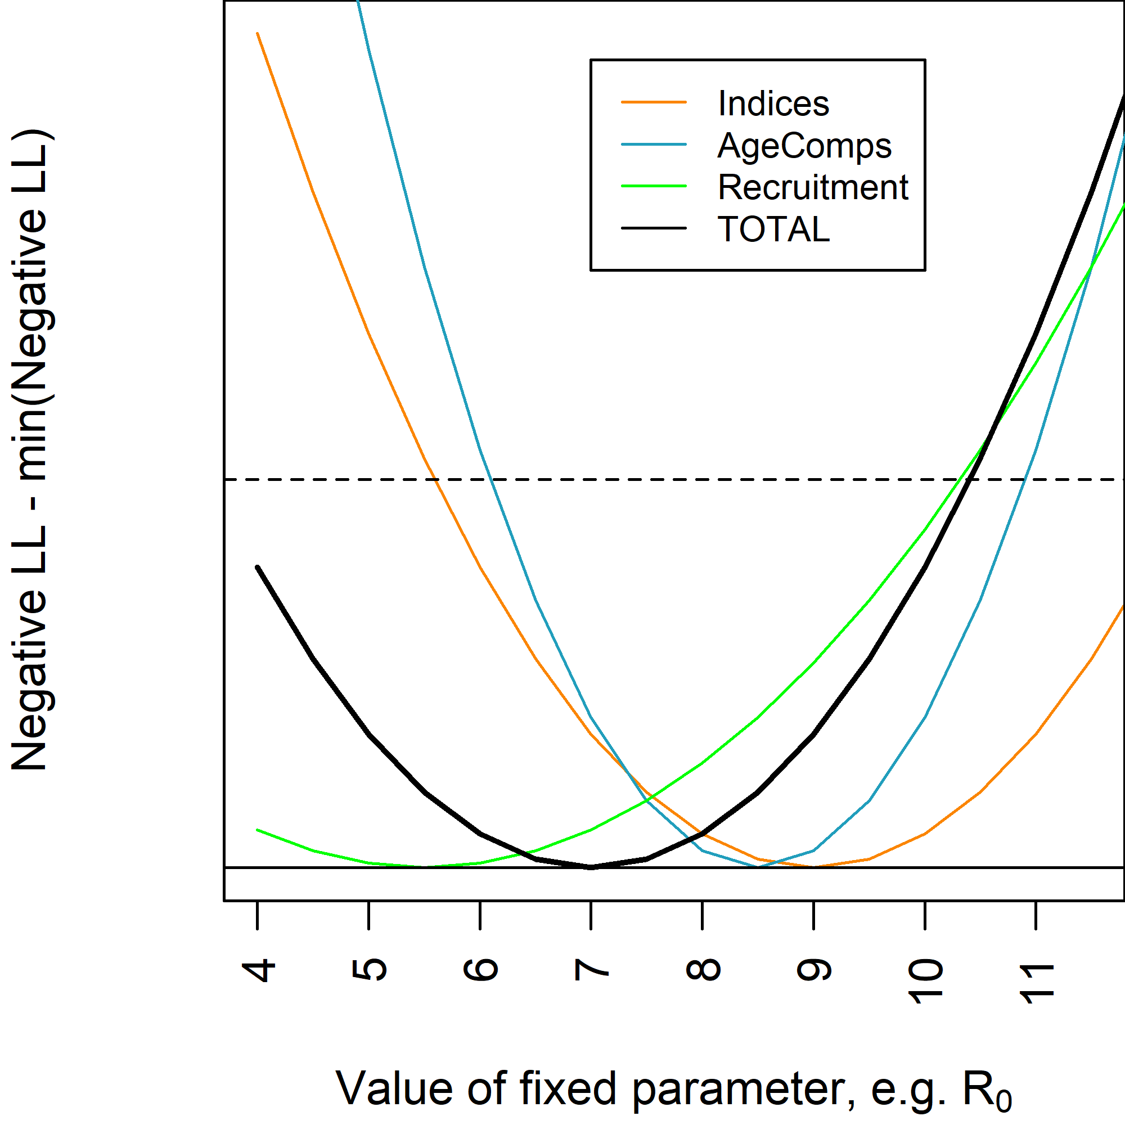

### **4.9.7. Retrospective analysis (within model)**

Iteratively remove years of data from the base model starting with the most recent year; the maximum retrospective length is up to the author, who should provide an explanation. Explain how time-varying quantities were treated during the retrospective period, if applicable. Show a single plot of the biomass time series with associated uncertainty intervals for each model run. Provide summary text indicating a) whether or not a retrospective pattern is visually present (i.e., outside confidence intervals of the base model); b) whether or not any retrospective pattern is positive (years with less data have systematically lower biomass estimates) or negative; c) the cause of any retrospective patterning, if known.

Example text: “A ten-year retrospective analysis was conducted by sequential removal of all data annually beginning with 2024 and ending in 2015 (Figure X). By age ten, a cohort of fish have reached their asymptotic length, are 80% mature and fully selected by the survey. Natural mortality is time-blocked in the ten-year span covered, this analysis sets *M* to the mean of the two time blocks for every peel. The mean terminal spawning biomass estimate from each of these retrospective models lies within the 95% confidence interval of the current base model, and there was a slight negative pattern to the trends (whereby years with less data had systematically higher biomass estimates). This does not present an immediate population concern as a negative retrospective bias results in more conservative harvest advice. The grouping of retrospective runs at three-year intervals is consistent with the frequency at which survey data are updated, combined with female age-at-maturity.”

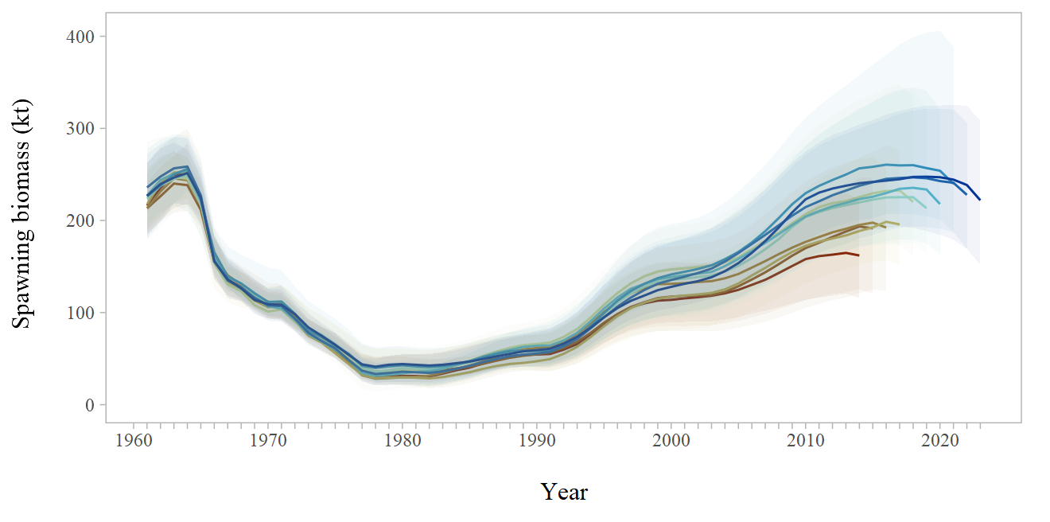

### **4.9.8. Historical retrospectives (between models)**

Provide a figure comparing the time series of biomass from the last several assessments accepted for management and the proposed base model, with uncertainty intervals. The author may choose to show only recent Full assessments, all assessments for the last *n* cycles, or some combination thereof, at their discretion. Provide a brief summary of how the current assessment compares to the historical perception of the stock, and the cause of any obvious differences.

Example Text: “Figure X compares the time series of spawning biomass from Model 24.0 and assessment models accepted for management, 2010-present, and associated 95% confidence intervals. The current assessment model is qualitatively similar to all models used for management advice from 2015 onwards, coinciding the change from dome-shaped to asymptotic fishery selectivity, the inclusion of age data from the bottom trawl survey, and the elimination of a restrictive prior on survey catchability *q*.”

## 4.10. Results: Tier 4-6

Provide a list of parameters that are estimated independently of the model (e.g., the natural mortality rate, parameters governing the maturity schedule, parameters governing growth [length at age, weight at length or age]). Include an explanation of how these parameters are estimated (methods do not necessarily have to be statistical; e.g., *M* could be estimated by referencing a previously published value).

Provide documentation of model results including text to interpret tables and figures. Describe and interpret notable differences between alternative models if applicable. Discuss fits to data and report error estimates and compare results between the previous and this year’s assessment.

## 4.11. Projections and Harvest Recommendations

Items in this section pertain to the authors’ recommended model or approach. If the structure of the recommended model or approach differs substantially from the model or approach most recently accepted by the SSC after reviewing either last year’s final SAFE report or the current year’s preliminary SAFE report, a set of parallel results and required biological reference points for the previously accepted model or approach should be included in an attachment.

### **4.11.1. Amendment 56 Reference Points**

Amendments 56 and 56 to the GOA and BSAI Groundfish Fishery Management Plans (FMPs) define ABC and OFL for the groundfish fisheries, where the fishing mortality rate is denoted *F*, stock biomass (or spawning stock biomass, as appropriate) is *B*, and the *F* and *B* levels corresponding to MSY (or proxies).

Amendments 56 specifically define the fishing mortality rate used to set OFL (*FOFL*), the maximum permissible ABC, and the fishing mortality rate used to set the maximum permissible ABC (max *FABC*). The fishing mortality rate used to set ABC (*FABC*) may be less than this maximum permissible level, but not greater. The overfishing and maximum allowable ABC fishing mortality rates are given in terms of unfished female spawning biomass (*F*SPR%), on fully selected age groups, where unfished female biomass is the average biomass if fishing had not occurred and is estimated as the historical biomass prior to fishing. The reference points are calculated using the long-term average female spawning biomass that would be expected under average estimated recruitment (state time series of years used). If there are time-varying biological or fishery parameters in the assessment model, describe how the reference rates were calculated.

Provide parameters, stock size estimates, and biological reference points (or best available proxies thereof) required by limit and target control rules specified in the fishery management plan.

### **4.11.2. Specification of OFL and Maximum Permissible ABC**

Specification of *FOFL* (Tiers 1-5 only), OFL, and the maximum permissible *FABC* (Tiers 1-5 only) or maximum permissible ABC (Tier 6 only).

For stocks managed under Tiers 4-5, in addition to estimates of stock size based on last year’s estimation procedure, include stock size estimates using the random effects model code provided in the *rema* R package. Also, for the biomass estimate used in the harvest control rule, include at least one measure of uncertainty such as standard error, *CV*, or 95% confidence interval (for stocks managed as complexes, report the uncertainty for the complex-wide survey biomass estimate, (not just the individual stocks). Document how this measure of uncertainty is calculated.

### **4.11.3. Standard Harvest Scenarios and Projection Methodology: Tiers 1-3**

A standard set of projections is required for each stock managed under Tiers 1, 2, or 3, of Amendments 56. This set of projections encompasses harvest scenarios designed to satisfy the requirements of Amendments 56, the National Environmental Policy Act, and the Magnuson-Stevens Act (MSA).

State and reference software used for projections (e.g., spmR, Stock Synthesis 3).

Repository: <https://github.com/afsc-assessments/spmR>

Documentation with examples: <https://afsc-assessments.github.io/spmR/index.html>

In the event that catch is likely to be less than the recommended ABC in either of the first two projection years, *Scenario 2* must be conducted, using the best estimates of catch in those two years (otherwise, *Scenario 2* can be omitted if the author’s recommended ABCs for the next two years are equal to the maximum permissible ABCs). In each subsequent year, the fishing mortality rate is prescribed on the basis of the spawning biomass in that year and the respective harvest scenario. Five of the seven standard scenarios support the alternative harvest strategies analyzed in the Alaska Groundfish Harvest Specifications Final Environmental Impact Statement. These five scenarios, which are designed to provide a range of harvest alternatives that are likely to bracket the final TACs for the next 2 fishing years, are as follow (“max *FABC”* refers to the maximum permissible value of *FABC* under Amendments 56, *assessment yr* = year the assessment is conducted for the following year’s fishery).

*Scenario 1*: In all future years, *F* is set equal to max *FABC*. (Rationale: Historically, TAC has been constrained by ABC, so this scenario provides a likely upper limit on future TACs.)

*Scenario 2*: In all future years, *F* is set equal to a constant fraction (“author’s *F*”) of max *FABC*, where this fraction is equal to the ratio of the *FABC* value for *assessment yr+1* recommended in the assessment, to the max*FABC* for *assessment yr+1*, and catches for *assessment yr+1 and yr+2* are estimated at their most likely values given the assessment *yr+1 and yr+2* recommended ABCs under this scenario. (Rationale: When *FABC* is set at a value below max *FABC*, it is often set at the value recommended in the stock assessment; also, catch tends not to equal ABC exactly.)

*Scenario 3*: In all future years, *F* is set equal to the *assessment yr-5* to *assessment yr-1* average *F*. (Rationale: For some stocks, TAC can be well below ABC, and recent average *F* may provide a better indicator of *FTAC* than *FABC*.)

*Scenario 4 (optional)*: In all future years, the upper bound on *FABC* is set at a selected fraction of *FABC*. (Rationale: This scenario provides a likely lower bound on *FABC* that still allows future harvest rates to be adjusted downward when stocks fall below reference levels.). This scenario is optional and is up to the author's discretion. If *Scenario 4* is presented, state the selected fraction of *FABC* used in the projection.

*Scenario 5*: In all future years, *F* is set equal to zero. (Rationale: In extreme cases, TAC may be set at a level close to zero.)

Two other scenarios are needed to satisfy the MSFCMA’s requirement to determine whether a stock is currently in an overfished condition or is approaching an overfished condition. These two scenarios are as follows (for Tier 3 stocks, the MSY level is defined as *B35%*):

*Scenario 6*: In all future years, *F* is set equal to *FOFL*. (Rationale: This scenario determines whether a stock is overfished. If the stock is 1) above its MSY level in *assessment yr+1* or 2) above 1/2 of its MSY level in *assessment yr+1* and expected to be above its MSY level in *assessment yr+10* under this scenario, then the stock is not overfished.)

*Scenario 7*: In *assessment yr+1 and yr+2*, *F* is set equal to max *FABC*, and in all subsequent years, *F* is set equal to *FOFL*. (Rationale: This scenario determines whether a stock is approaching an overfished condition. If the stock is 1) above its MSY level in *assessment yr+2* or 2) above 1/2 of its MSY level in *assessment yr+1* and expected to be above its MSY level in *assessment yr+12* under this scenario, then the stock is not approaching an overfished condition.).

For Tiers 1-3, provide:

* Table of 13-year projected catches (starting with *assessment yr*) corresponding to the alternative harvest scenarios, using stochastic methods if possible (mean values or other statistics may be shown in the case of stochastic recruitment scenarios).
* Table of 13-year projected spawning biomass corresponding to the alternative harvest scenarios, using stochastic methods if possible (mean values or other statistics may be shown in the case of stochastic recruitment scenarios).
* Table of 13-year projected fishing mortality rates corresponding to the alternative harvest scenarios, using stochastic methods if possible (mean values or other statistics may be shown in the case of stochastic recruitment scenarios).

Include a discussion on how current and two future year catches are estimated. These catches should be included in the harvest scenario table under Scenario 2 and noted in the Executive Summary Table.

## 4.12. Risk Table and ABC Recommendation

Include the [risk table template](https://docs.google.com/document/d/1gG7qeZlWjbHeG47hmHkWoysqoMaaJcJZwMQpZ_lNds4/edit) along with an evaluation and score of each of the four considerations.

Include a summary table with scores and an explanation if this information supports a scientific recommendation to reduce the ABC from the maximum permissible.

If a reduction is warranted, authors may choose either to recommend a specific amount, or to recommend that the SSC determine the amount. If a specific reduction is recommended and the stock or complex is managed under Tiers 1- 3, the *FABC* and ABC recommendations should correspond to Scenario 2, where - current catch and catches for the next two years were estimated as described in the preceding section.

## 4.13. Area Allocation of ABC

If area apportionment of ABC is used or recommended, include a subsection titled “Area Allocation of ABCs,” with results and details of the apportionment scheme(s) for upcoming year and the next.

* Discussion of whether there is biological evidence for a regional management approach. If a regional management approach is desirable for the stock, but there is insufficient data for it, what is the research and data needed to address this issue?
* For stocks where current practice is to allocate ABCs by management area, a standard data product (e.g., the proportion of the survey biomass in each management area) can be provided as the basis for discussions regarding ABC allocation.
* Include reference to stock structure template and summary if previously completed

## 4.14. Status Determination

Under the MSFCMA, the Secretary of Commerce is required to report on the status of each U.S. fishery with respect to overfishing. This report involves the answers to three questions: 1) Is the stock being subjected to overfishing? 2) Is the stock currently overfished? 3) Is the stock approaching an overfished condition?

State whether:

1. The stock/complex is being subjected to overfishing (determined by comparing the catch from the most recent complete year to the specified OFL for that year) (Tiers 1-5),
2. The stock/complex is overfished (Tiers 1-3 only), and
3. The stock/complex is approaching a condition of being overfished (Tiers 1-3 only).

## 4.15. *Flimit*

Report the *F* (based on the author’s recommended model) that would have produced a catch for last year equal to last year’s OFL. This value is reported in the SARA files as the F_LIMIT and included in the species information system (SIS) output. Two simple options for making this calculation are provided below, but authors are free to write their own code if they prefer:

1. Use [this spreadsheet](https://docs.google.com/spreadsheets/d/1AeaVCSJqnh0kV6_zSPbK41Z2fBsxmsHsY66B36FTPoY/edit#gid=907492102) (note that separate tabs provide options for models with one sex and one gear, two sexes and two gears, and two sexes and two gears with sex-specific *M*). The units are kt for OFL, kg for weight at age, and millions of fish for numbers at age. Zeros can be inserted for unused ages.
2. For models developed in Stock Synthesis, replace last year’s catch in the data file with last year’s OFL, set maximum phase to 0 in the starter file, and re-run SS from the *.par file (the answer will be listed in the report file as “F_20yy,” where 20yy is the previous year). A similar procedure will likely work for many non-SS assessment models programmed in ADMB.

## 4.16. Ecosystem Considerations

Authors are encouraged to use information contained in the Ecosystem Status Report to assist them in developing stock-specific analyses and to recommend new information for inclusion in future versions of the Ecosystem Status Report. Time series currently contained in the Ecosystem Status Report may simply be referenced rather than duplicated here. In cases where stock-specific time series or relationships are used, this information should be included here rather than in the Ecosystem Status Report. In the event that an Ecosystem and Socioeconomic Profile is provided, this section can be omitted.

## 4.17. Ecosystem Effects on the Stock

The following factors should be discussed:

1. Prey availability/abundance trends (historically, in the present, and in the foreseeable future). These prey trends could affect growth or survival of a target stock.
2. Predator population trends (historically, in the present, and in the foreseeable future). These trends could affect stock mortality rates over time.
3. Changes in habitat quality (historically, in the present, and in the foreseeable future). Changes in the physical environment such as temperature, currents, or ice distribution could affect stock migration and distribution patterns, recruitment success, or direct effects of temperature on growth.

## 4.18. Fishery Effects on the Ecosystem

The following factors should be discussed:

1. Fishery-specific contribution to bycatch of prohibited species, forage (including herring and juvenile pollock), HAPC biota (in particular, species common to the target fishery), marine mammals, birds, and other sensitive non-target species (including top predators such as sharks, expressed as a percentage of the total bycatch of that species.
2. Fishery-specific concentration of target catch in space and time relative to predator needs in space and time (if known) and relative to spawning components.
3. Fishery-specific effects on the amount of large-size target fish.
4. Fishery-specific contribution to discards and offal production.
5. Fishery-specific effects on age at maturity and fecundity of the target species.
6. Fishery-specific effects on EFH non-living substrate (using gear specific fishing effort as a proxy for amount of possible substrate disturbance).

## 4.19. Data Gaps and Research Priorities

Describe research and data needs and specify their priority (high, medium, low). Focus on areas where a significant improvement in the amount of available information would likely result in a significant improvement in the quality of the assessment and the estimates of critical parameters.

## 4.20. Acknowledgements

Include reviewers and affiliations as well as names and affiliations of persons who contributed data, advice or information but were not part of the assessment team.

## 4.21. Literature Cited

List all references cited in the assessment (and make sure that the current assessment cites appropriate previous assessments containing any analyses that are still mentioned but no longer included in the current assessment).

Omit all references not cited in the assessment (i.e., vestigial references from previous assessments).

## 4.22. Auxiliary Files

A list naming the required text files (complete parameter and data/input files in the native code of the stock assessment program), model executable, and any other supplementary electronic files that will accompany the assessment document when archived.

## 4.23. Tables

## 4.24. Figures

## 4.25. Appendices and Working Papers

Documents with supplementary material in support of the stock assessment document may be included in the SAFE report as appendices or working papers, as appropriate. These are products other than auxiliary files (described above).

Appendices are defined as work products that directly support, document, or are used in the stock assessment model. These may be data analyses that produce data used in the stock assessment model (eg. fishery data CPUE index or natural maturity evaluation), research models for presentation but not for use in management advice, or supporting research that directly affects data used in the assessment model or the model configuration. Authorship of appendices may or may not be independent of stock assessment authorship, which will follow the [AFSC stock assessment authorship policy](https://docs.google.com/document/d/12q1CDpfWkOYi9CoJks-KPrHRY_JerIE7qRmm8__6WgI/edit).

Working papers are defined as SAFE contributions that complement the stock assessment as a substantial stand alone product. Working papers may be unpublished technical documents that provide substantial contributions to the stock assessment and fishery management process (eg. multispecies modeling results). Authorship may be independent of the stock assessment as the intention is to provide recognition for significant work products.These documents are intended to be stand-alone SAFE products for posting alongside each stock assessment.

Appendices and working papers should follow the same formatting guidelines as a stock assessment document and list authors that may or may not include the stock assessment lead author. Lead authors of appendices and working papers are responsible for submitting and posting documents independently of the stock assessment document, and following the same deadlines provided for stock assessments. The lead assessment author should be made aware of any appendix/working paper being posted and provide support/review as needed. Appendices and working papers require internal review prior to posting publicly. Authors of appendices and working papers should work with their supervisor to ensure proper internal review occurs.

# 5. Harvest Projection Guidelines

Harvest projections are brief discussions of the results of running projections for setting the next two year’s specifications. For Tiers 1-3 the harvest projections ***do not*** involve re-running the assessment model, only running the projection model with updated catch information. In addition to running the projection model and discussing results, a brief discussion of updated survey biomass trends and catch/biomass ratios should be included.

Harvest projections for Tiers 4-5 stocks do not have projection models, and ***do not*** involve re-running the random effects REMA model. Instead, catch/biomass ratios should be reported along with survey biomass estimates during years with new survey data.

# 5.1. Title Page and Authorship

Please use the following convention: “Assessment of the Myfish stock in the Gulf of Alaska” for single-stock assessments and “Assessment of the Myfish stock complex in the Gulf of Alaska” for multi-stock assessments (replacing italicized text appropriately).

Authorship shall be decided following the [AFSC stock assessment authorship guidelines](https://docs.google.com/document/d/12q1CDpfWkOYi9CoJks-KPrHRY_JerIE7qRmm8__6WgI/edit).

The title page should include text on how to cite the assessment document, based on the following example.

This report may be cited as:

Authors., Year. Title. North Pacific Fishery Management Council, Anchorage, AK. Available from https://www.npfmc.org/library/safe-reports/

## 5.2. Executive Summary

Short description of stock assessment cycle and reference to last full assessment (with link). Statement on when the next full stock assessment will be conducted. Short description of tier, projection model, data sets used, and what is included in a harvest projection year for this stock.

### **5.2.1. Description of Updated Catch**

List of changes (if any) in the input catch data, including estimated catches assumed for the current year and projected catches for current year + 1 and current year + 2. Provide a brief description of updated factors (if any) related to including the catch data in the projection model (e.g. expansion factor or yield ratio).

Harvest projection assessments are due for the September GPT meetings. Authors should query the most recent catch estimates from AKFIN on or soon after August 1. Catch estimates for use in projection models should be extrapolated to the full year ending on December 31 with rationale for how the extrapolation is done.

### **5.2.2. Summary of Results**

Provide information in the text table following the harvest projection table template below.

Provide the Fishery section with a text table of new catch data (typically current year -1, and current year) and brief description of any notable trends.

Provide Survey section with discussion of new survey estimates (if any) and brief description of any notable spatial/temporal trends.

Provide a table of the area apportionments (if any) for the recommended one- and two-year ahead ABCs and OFLs along with a brief description of apportionment methodology.

### **5.2.3. Harvest Projection Template**

| Quantity | As estimated or  specified last year for: | | As estimated or  recommended this year for: | |
| --- | --- | --- | --- | --- |
| current year | current year + 1 | current year + 1 | current year + 2 |
| M (natural mortality rate) |  |  |  |  |
| Tier |  |  |  |  |
| Biomass (t) |  |  |  |  |
| FOFL |  |  |  |  |
| maxFABC |  |  |  |  |
| FABC |  |  |  |  |
| OFL (t) |  |  |  |  |
| maxABC (t) |  |  |  |  |
| ABC (t) |  |  |  |  |
| Status | As determined last year for: | | As determined this year for: | |
| current year − 2 | current year − 1 | current year − 1 | current year |
| Overfishing |  | n/a |  | n/a |

### **5.2.4 Figures**

For all Tiers where applicable, provide a figure of new survey estimates (from what the author considers the primary survey) with 95% confidence intervals.

For Tier 3 and above, provide a figure of modeled catch divided by modeled total biomass, where catch and biomass estimates for any updated year should come from the projection model to incorporate newly complete or expanded catches.

For Tiers 4-5, provide a figure of observed catch divided by observed survey biomass estimates or observed catch divided by biomass estimates from the random effects model.

# 6. References: Alaska Groundfish Stock Assessment Guidelines

Aki Vehtari, Andrew Gelman, Daniel Simpson, Bob Carpenter, Paul-Christian Bürkner "Rank-Normalization, Folding, and Localization: An Improved Rhat for Assessing Convergence of MCMC (with Discussion)," Bayesian Analysis, Bayesian Anal. 16(2), 667-718, (June 2021)